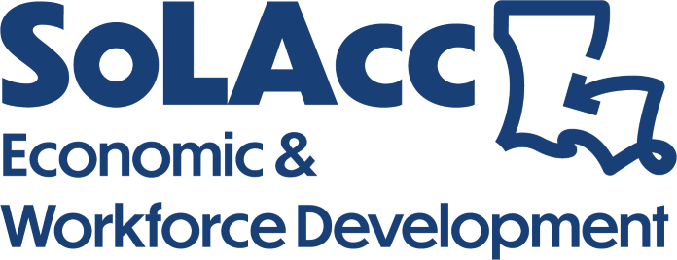 | NC Welding Combined  Industry Based Credential  2025-2026
YMAU 1301 | NCCER Core | 40
IBC Name: NCCER Core Curriculum
CIP CODE: 469999

 | Welding Level 1 | 172
IBC Name: NCCER Plumbing Level I
CIP CODE: 480508

 | Welding Level II | 172
IBC Name: NCCER Plumbing Level II
CIP CODE: 480508

TOTAL PROGRAM Clock Hours |  | 384
TOTAL Weeks |  | 24

Program Description

The SLCC Welding curriculum prepares learners for a career as skilled welders. participants will delve into a variety of welding processes, such as oxyfuel cutting, shielded metal arc welding, and plasma arc cutting, covering SMAW, FCAW, GMAW, and GTAW techniques.

Level 1 will showcase fundamental welding proficiencies encompassing safety protocols, oxyfuel cutting techniques, metal surface preparation, plasma arc cutting methodologies, air-carbon arc cutting and gouging procedures, base metal conditioning, assessment of weld quality, joint fitting and alignment practices, as well as preheating and post-heating methodologies for metals. Additionally, students will gain proficiency in Shielded Metal Arc Welding (SMAW) and other essential skills vital to welding processes.

Level 2 will introduce advanced welding techniques. This includes proficiency in interpreting welding symbols and reading detailed welding drawings, as well as understanding the physical characteristics and mechanical properties of various metals. Students will become adept in operating Gas Metal Arc Welding (GMAW), Flux-Cored Arc Welding (FCAW), and Gas Tungsten Arc Welding (GTAW) equipment on different types of plates and materials.

This program is 384 clock hours including lecture and lab. Successful completion of this program prepares the student for employment as an entry level welder.

Program Cost
$6000

Campus Locations
Lafayette, New Iberia, St. Martinville, Baldwin

